LLM-RAG based startup idea feasibility and market validation engine

ABSTRACT
In the rapidly changing startup environment, evaluating a new business idea is difficult because market demand, customer expectations, competitor activities, pricing, technology trends, and industry conditions can change within a short period. Traditional validation methods often depend on manual research, historical datasets, or isolated sources, making the assessment time-consuming and potentially outdated. To address these challenges, this project proposes an LLM-RAG Based Startup Idea Feasibility and Market Validation Engine that combines real-time information retrieval, Retrieval-Augmented Generation (RAG), and multi-agent artificial intelligence. The system collects relevant and recent information from market sources, government datasets, research publications, customer feedback, news, and competitor information. The RAG component retrieves the most relevant evidence from the collected knowledge base and provides it to a large language model for context-based analysis. Specialized agents independently examine market demand, customer pain points, competitors, market gaps, technical feasibility, business potential, and associated risks. A scoring mechanism then combines these factors to generate an overall feasibility score, while evidence confidence is used to indicate the reliability of the assessment. Based on the findings, the system provides an actionable recommendation, such as developing the idea, modifying it, performing further validation, or reconsidering it. The proposed approach aims to provide a faster, transparent, evidence-based, and continuously updateable solution for startup idea evaluation and market validation.
Keywords: Large Language Model (LLM), Retrieval-Augmented Generation (RAG), Startup Feasibility Analysis, Market Validation, Real-Time Market Intelligence, Multi-Agent AI, Competitor Analysis, Customer Pain-Point Detection, Market Gap Detection, Evidence-Based Decision Support, Feasibility Scoring, Explainable AI

Existing System
Existing startup evaluation systems generally rely on historical startup data, manual market research, conventional machine learning models, or general-purpose large language models to assess business potential. These approaches examine factors such as market conditions, competitors, financial information, and business characteristics to estimate the likelihood of startup success. Some systems also use web search and document analysis to support due-diligence activities. However, the assessment often depends on previously collected information and may not fully capture recent changes in customer needs, competitor strategies, market trends, or emerging opportunities. As a result, startup evaluation can remain time-consuming, less transparent, and difficult to update when market conditions change.
Disadvantages:
- Dependence on historical or limited data can result in outdated startup evaluations when market conditions change rapidly.
- LLM-based analysis may produce unsupported or inaccurate conclusions when sufficient evidence is not available.
- Existing approaches provide limited analysis of customer pain points and unexplored gaps between market needs and competitor offerings.
- Startup success prediction does not always provide an understandable feasibility score with evidence-based recommendations for improving the proposed idea.

Proposed System
The proposed system introduces an LLM-RAG based startup feasibility and market validation framework that combines real-time information retrieval, Retrieval-Augmented Generation (RAG), multi-agent AI, and quantitative scoring. The system collects recent information from market sources, government datasets, research publications, customer feedback, news, and competitor information. The RAG module uses Sentence Transformers and ChromaDB to store and retrieve relevant evidence, which is then provided to a Large Language Model (LLM) for grounded analysis. Specialized agents analyze market demand, competitors, customer pain points, market gaps, technical feasibility, business potential, and risks. Finally, a feasibility engine combines these factors to generate an overall score, confidence level, and actionable recommendation.
Advantages:
- Real-time information retrieval helps provide startup evaluations based on recent market trends, customer needs, and competitor activities.
- RAG connects LLM responses with relevant evidence, reducing unsupported information and improving the reliability of generated analysis.
- Multi-agent analysis examines different business factors independently, providing a more detailed and comprehensive feasibility assessment.
- Evidence-based scoring and confidence analysis provide transparent recommendations that help users understand the strengths, weaknesses, opportunities, and risks of their startup idea.

Modules Description:

- Startup Idea Input Module: This module allows the user to enter a startup idea and submit it for feasibility and market validation.
- LLM-RAG Analysis Module: This module processes the startup idea using LLM-RAG to retrieve relevant information and generate evidence-based analysis.
- Market Analysis Module: This module identifies the target market, relevant problems, market evidence, and supporting sources related to the startup idea.
- Customer Pain Analysis Module: This module identifies customer pain points, categories, severity, and supporting evidence from the target market.
- Competition Analysis Module: This module analyzes the competitive landscape, identifies competitors, and evaluates competitive strength.
- Market Gap Analysis Module: This module identifies unresolved problems and potential market gaps using the retrieved evidence.
- Technical Feasibility Module: This module evaluates technical requirements, technical signals, technical risks, and implementation feasibility.
- Validation Score Module: This module calculates the overall validation score using market evidence, customer pain, competition, market gap, and technical feasibility.
- Final Validation Report Module: This module generates a consolidated report containing the startup summary, target market, customer pain points, market evidence, validation score, recommendation, and evidence limitations.

System Architecture

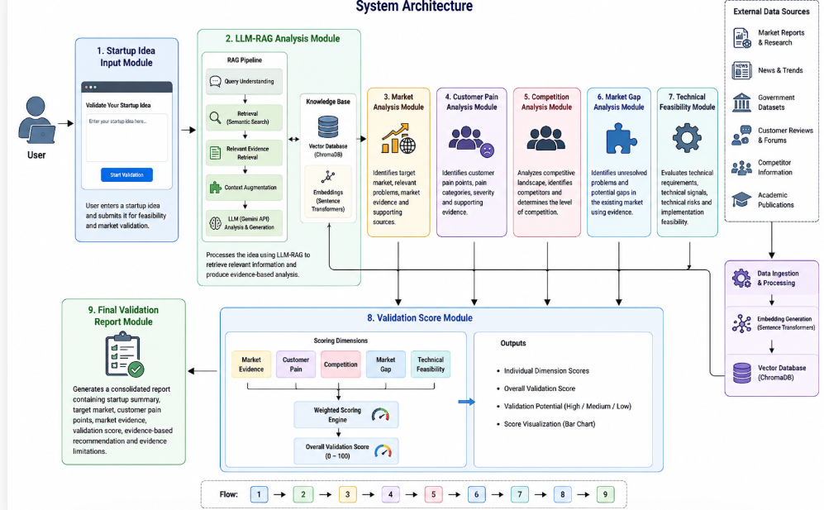

HARDWARE & SOFTWARE REQUIREMENTS:
HARDWARE REQUIRMENTS:
- Processor : Intel I3 (min)
- Hard Disk : 500 GB (min).
- Ram : 8 GB (min).
SOFTWARE REQUIRMENTS:
- Operating system : Windows 10 (min)
- Coding Language : python 3.11 or above
- Web Framework : Streamlit

